Name: Truong Dang Truc Lam  
ID: B2111933   
Class: CT209H-M04

# LAB 6

## Exercise 1: Creating a Starter GPO

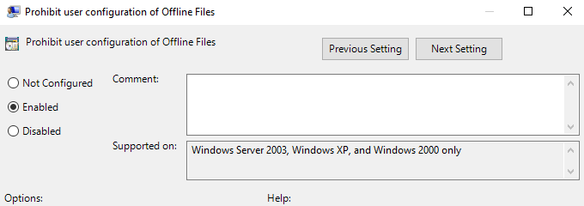

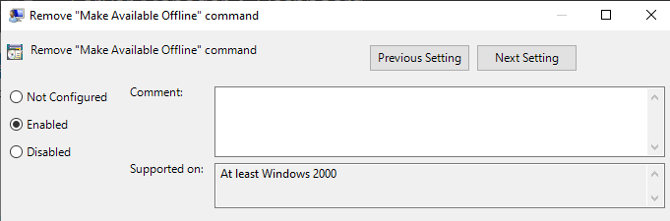

Create a Starter GPO to serve as a template

## Exercise 2 Creating Group Policy Objects

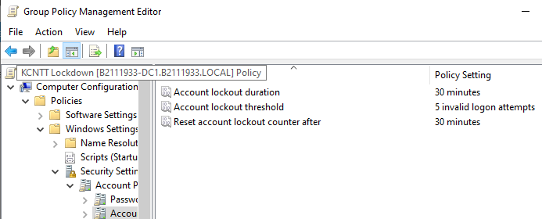

Adjust the account lockout policies to prevent unauthorized access

## Exercise 3 Linking a Group Policy Object

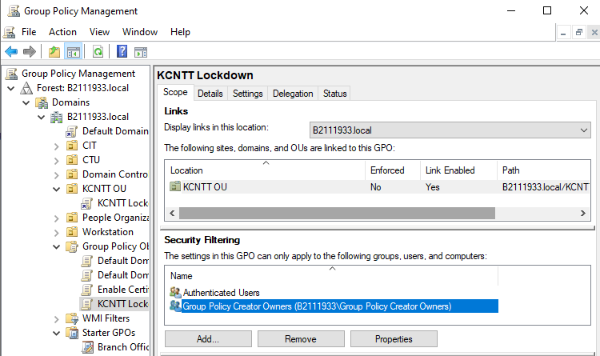

However, I cannot find any “Servers” object

## Lab Challenge Confirming GPO Application

## Exercise 4: Configuring Security Policies

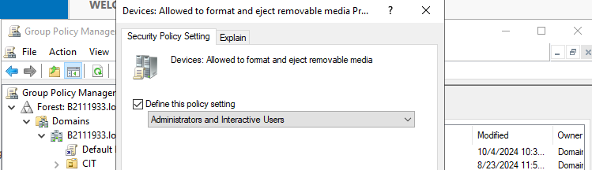

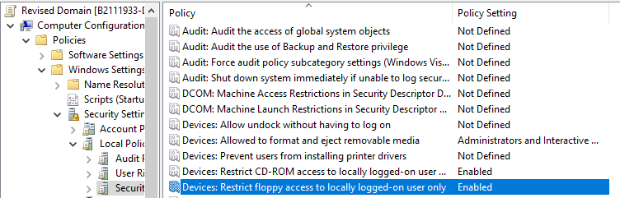

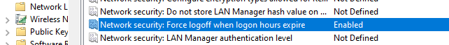

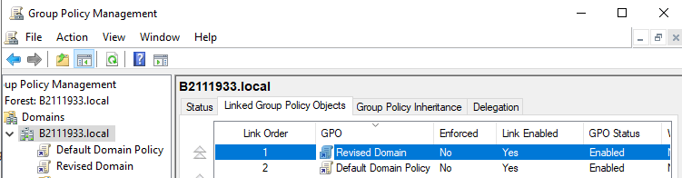

In Group Policy, the settings from higher-precedence GPOs will overwrite conflicting settings from those that have lower-precedence. By placing the Revised Options GPO first, its settings will take effect even if there are other GPOs linked to the domain that might have different configurations for the same policies.

## Lab Challenge: Assigning User Rights

I have followed these steps:

1. Create the Directors Group
2. Add Users to the Directors Group
3. Assign User Rights to the Directors Group with Revised Domain Policy:

(Right click Revised Domain > Edit > Computer Configuration > Policies > Windows Settings > Security Settings > Local Policies > User Rights Assignment)

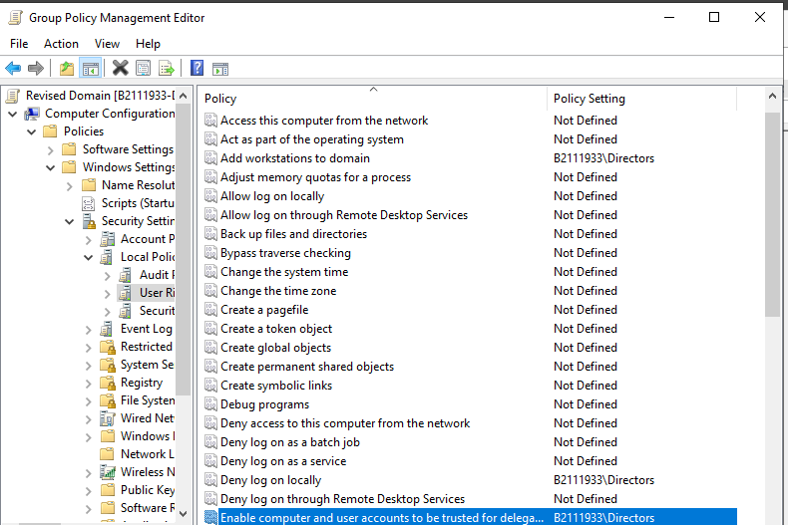

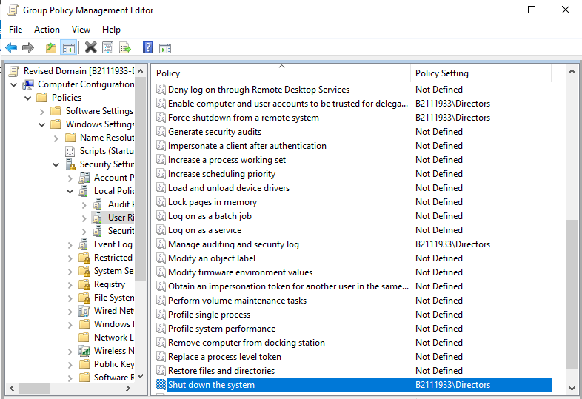

Assign user rights to Directors group

## Exercise 5: Configuring Audit Policies

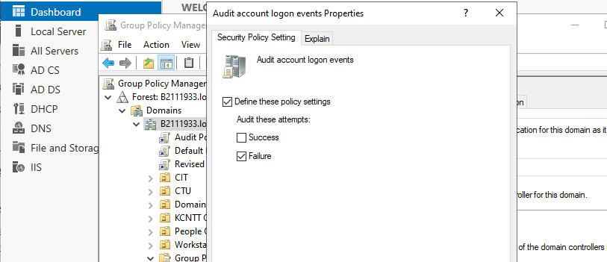

Configure Audit Policies for logon events

*Why, in this case, is the auditing of event failures more useful than the auditing of successes?*

Answer: Auditing event failures is more useful than auditing successes because it helps identify unauthorized attempts to log on to accounts or access specific objects.

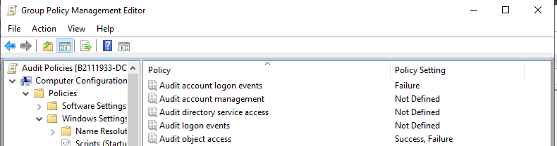

Configure Audit Policies for object access

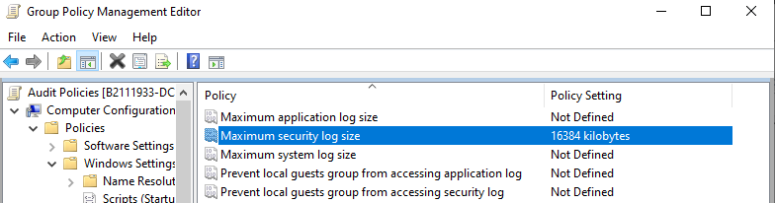

Set Maximum security log size to 16384 kilobytes

*Why is it prudent to limit the event log size when using auditing?*

Limiting the event log size when using auditing is prudent to prevent the log from   
filling up and causing system performance issues. Additionally, it can help us focus on important events and avoid being overwhelmed by unnecessary information.

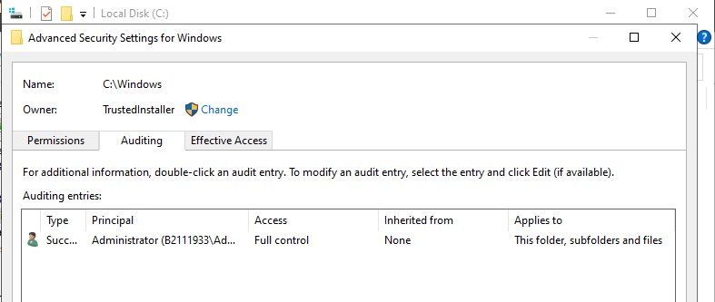

Configure auditing for the Administrator

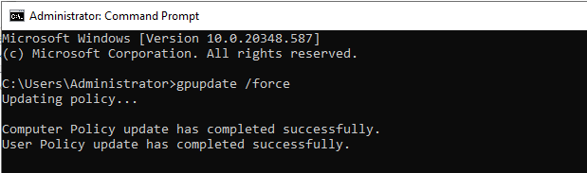

User Policy update completed

## Lab Challenge: Viewing Auditing Data

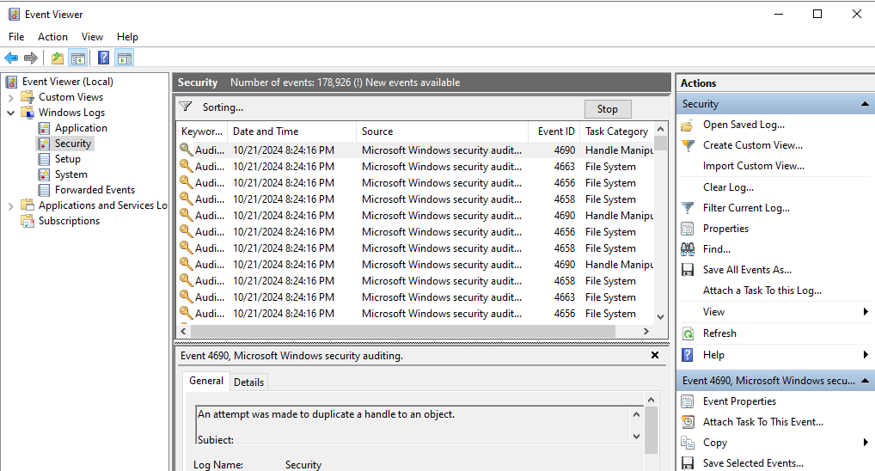

Viewing auditing data

## Lab 6: Configuring GPO to map A network drive

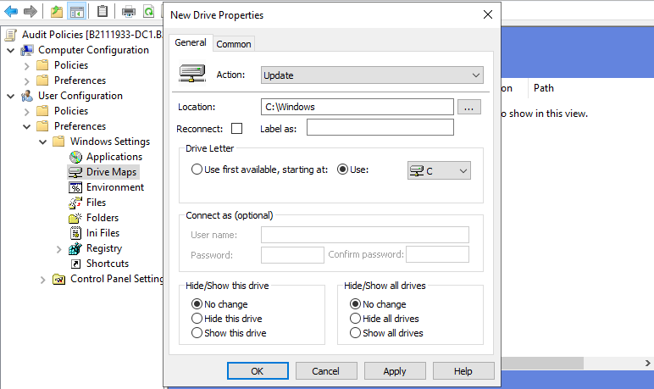

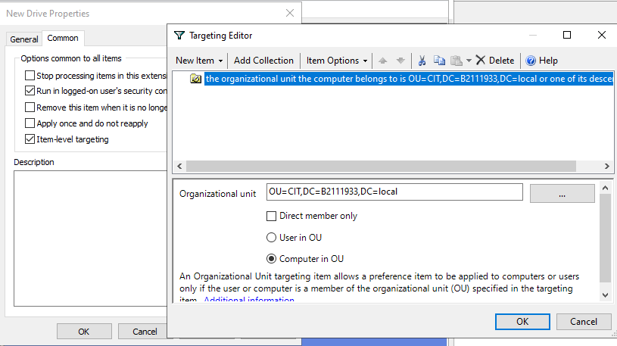

Configure GPO to map A network drive